

**Student Number: 322786**

**Word Count: 1854**

**MSc in Management**

**2019-2020**

**Module Title**

Strategic Management

**Assessment Type**

Individual Assignment

This report is all my own work and conforms to the University’s regulations on plagiarism

**Porter's Five Forces Analysis – Soft Drink (Beverages) Industry**

**Bargaining power of buyers:**

The consumer switches brand when it comes to the pricing of drinks based on how expensive it is. High drink prices can trigger consumer losses. So to attract the customers, the companies are providing the consumers with enticing like winning tickets, and several more. Overall costs of rivals remain comparable and this is why buyers 'bargaining power remains weak.

**Bargaining power of suppliers:**

Industry vendors are manufacturers of bottling equipment, and suppliers of secondary packaging offer almost similar products. The number of suppliers of equipment is not in short supply and swapping suppliers is relatively easy for a business which takes away most of the negotiating power of suppliers.

**Threat of new entrants:**

A significant sum of money is needed for the purposes of manufacturing, bottling, delivery and storage in order to reach the beverage business but it may prove to be beneficial in the long term. The new entrants in this sector would have to face huge challenges because the existing ones have already established a strong footprint through all their networks, such as supermarkets, restaurants etc.

**Threats of substitutes:**

Usable alternatives do not have production drawbacks or high costs that will justify their usage in the soft drink market against the products because replacements are not priced at a very high level that their availability as a mainland commodity will be impacted. But most of the consumers don't quickly move between brands because of the market identity and the prestige that the businesses have gained over time in the industry.

**Rivalry among existing players:**

The overall growth rate in this industry is not very high, and the entrants don't have anything to bring as consumers already have their brand and their style that they want most. Now for the rivalry they also give different incentives, advertisements and promotion to retain their reputation.

(*4. Porter’s Five Forces - Soft Drink Industry SAR Analysis*, no date)

**Using the Customer Matrix to evaluate the competitive strategy**

A strategic approach can follow the satisfaction of a consumer's desires more successfully than any other direct or indirect competitor does by a better alignment between the product characteristics of a business and the expectations of its consumers. Use consumer experiences to illustrate a systematic process through which strategy leads to creating value. It visually demonstrates the strategic thinking by identifying cause and impact relationships from various viewpoints between objectives. The more the desires of the consumers are fulfilled by the combination of defined product attributes, the greater the amount of consumers who are drawn and sustained, resulting in revenue growth. The measures below for using the matrix are-

**Identify dimensions of PUV’s:**

Defining PUV's would be useful because consumers not only buy goods or services but also a variety of characteristics that are essentially the attributes, based on consumer preference and requirements.

**Target customer:**

Using the perceptual map, the business may classify its consumers according to their preferences and also recognise their worth engagement as a combination of product attributes of interest.

**PUV dimensions:**

In order to get the best outcome, consumer intervention is needed in terms of survey to ensure the specifics of the dimensions across the competitors. Along with the business score on certain dimensions, the weight of these variables provides the PUV for each firm. This will then be plotted in the consumer matrix on the vertical axis.

**Perceived price:**

Plotting the firms into the horizontal axis requires consumer input into how expensive a product they perceive. To this end, the survey will ask the consumers how costly the other firms 'product is on a ratio scale of 0 to 10.

**Customer matrix:**

The combination of the data obtained in the survey would show the position of all organisations in the customer matrix. This matrix would then function as a basis for a conceptual interpretation of the product's competitive effect in business.

**Criteria used to identify a ‘strategic asset’**

Applying the (1991) VRIN system for Barney will decide if a resource is a source of sustainable competitive advantage. To act as the basis for the sustainable competitive advantage, resources do need to be-

**Valuable:** A source of competitive advantage can be resources which can bring value. Remember not all services are equally easy to obtain.

**Rare:** Rareness means that the resource must be scarce in the sense that it is rare due to the demand or what it produces for its use.

**Imitability:** Consider the situation where a resource is unique and rare but can be quickly replicated by the competing organisations. These resources can not even serve as sources of competitive advantage.

**Non-substitutable:** The ideal resource is not replaceable with any other resource. When two tools can be used separately to execute the same strategy then they are equivalent strategically.

I found McDonald's three strategies after the evaluation, which they offer differently from their competitors.

1. **Brand image:** Copying the brand's strength would be challenging, and it would require significant effort and time for marketing. Trust is crucial in this era and McDonald's has a good brand image that shows trust among its consumers after the company has announced its valuation as 130368 million us dollars. (*•Fast food industry market share worldwide, by brand 2019 | Statista*, no date).
2. **Supply chain and technology:** McDonald's has the supply chain well handled, one of their biggest strengths. In addition, it invests in technologies across the supply chain, including internal and external contact and consumer service, and in other systems.
3. **Economies of scale:** Whereas other companies may try to imitate this. Few will purchase ingredients and packaging on a McDonald's scale. In 2018, the company invested 38% of its expenses on paper and food. (*How McDonald’s Wages and Major Costs Stack Up - Market Realist*, no date).

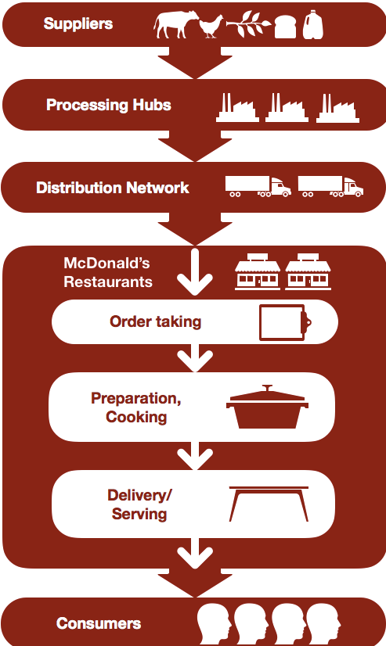(*McDonald’s VRIO/VRIN Analysis & Value Chain Analysis (Resource-Based View) - Rancord Society*, no date)

**Corporate parenting matrix**

A corporate parenting matrix summarises the specific decisions about the company/business unit fit for the organisation as a whole. Corporate parenting views the company in terms of resources and capabilities that can be used to create value for business units and produce synergies across business units. It creates corporate strategy by concentrating on the parent corporation's core competencies and the value generated by the parent's relationship to its businesses. There are essentially 3 types that can be used to combine corporate parenting framework which are financial control, strategic planning, and strategic control.

This matrix has two variables from which to assess market attractiveness. Benefit is one, and Feel is the other.

**Benefits:** In simple words, the opportunities to help are benefits. The more help the business can offer, the more value it can add.

**Feel:** Feel is the resemblance between the Parent and the potential company. Industry, organisational structure, culture, and law may determine the similarities. It is about critical success factors (CSF) in relation to the above mentioned elements.

Benefits and Feels combined offer the following types of business unit acquisition targets that differ in attractiveness depending on the situation.

1. **Alien:** Parent fits poorly with the SBU and can do little to support anyway. It can be said to have low benefits and low feelings too. Disposal is the only treatment for this type.
2. **Value trap:** The parent does not understand and can add value which may do more harm than good so, it is a bit risky. It can be said that it has high benefits with low feel. Parent can just work if they may transfer them to heartlands and for this parent needs to be able to know business with SBU.
3. **Ballast:** This is understood by parent, but can only add little value to them because it has high feel and low benefits. They need parent's light touch.
4. **Heartland:** This is understood by parent and parent continues to add value without risk of harming SBU. It has both high feel and high benefits. For the future such units must remain at the core of a business strategy.

Based on this matrix, and with inward approaches, company may help devise a plan for corporate acquisition and divestment.

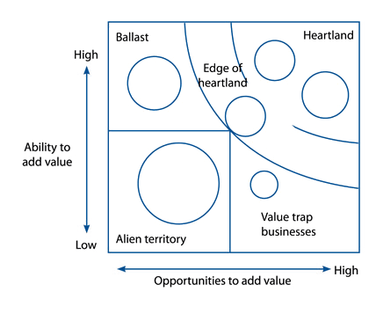(*Chapter 7: Methods of strategic development*, no date)

**Cultural web establishment**

During times of organisational transition culture is also the point of focus. In more competitive environments, cultural issues may be the result of low moral status, absenteeism or increased worker attrition, and of all the negative productivity implications.

The Cultural Web, founded in 1992 by Gerry Johnson and Kevan Scholes, is one of the ways to look at and improve the culture of the organisation. One can use it to reveal cultural theories and practices and set the operational elements to function in accordance with each other and with one’s strategy.

The Cultural Web distinguishes connected factors that together form the "paradigm," the concept or model, of which Johnson and Scholes speak. The broader image of corporate culture can be shown when examining the particular factors in each: what functions, what does not function and what should be changed. The elements are:

**Paradigms:** A self-consistent collection of ideas and beliefs that serve as filter, that affect how we view things and make sense of them.

**Stories:** Basically, it is the past activities and individuals talking about inside and outside the business. They show the principles that the organisation wants to implement.

**Rituals and routines:** People's everyday conduct and acts that signify appropriate behaviour. This decides what will actually happen in certain situations and what management values.

**Symbols:** The Company’s external depictions include logos, how the offices are plush and the formal or informal dress codes. They become the organization's self-explaining.

**Organisational structure:** The hierarchy defined in the chart and the unwritten power and control lines reflecting the contributions most esteemed.

**Control systems:** These include financial systems, metrics of quality (including how they are assessed and conveyed in the organisation) and motivation. The forms it regulates the company.

**Power structures:** It may include one or two senior managers, a group of management and even a department, the company's centres of actual control. The idea is that these individuals control policies, activities and strategic strategy the most.

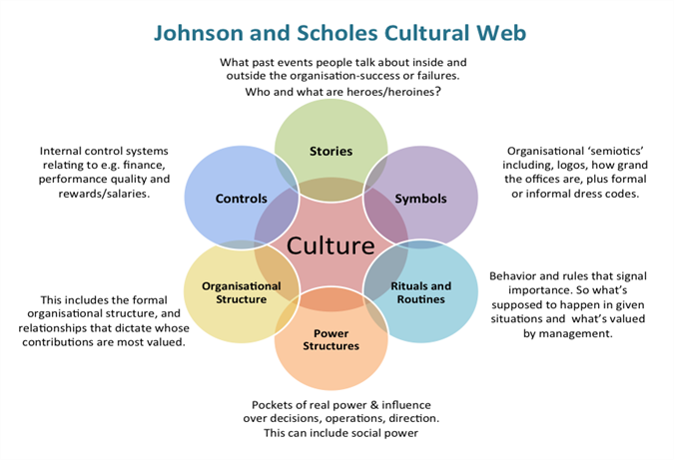(*Culture eats strategy for breakfast - The Management Centre*, no date)

**References**

*• Fast food industry market share worldwide, by brand 2019 | Statista* (no date). Available at: https://www.statista.com/statistics/273057/value-of-the-most-valuable-fast-food-brands-worldwide/ (Accessed: 2 April 2020).

*4. Porter’s Five Forces - Soft Drink Industry SAR Analysis* (no date). Available at: https://sites.google.com/site/softdrinkindustrysaranalysis/porter-s-five-forces (Accessed: 29 February 2020).

*Chapter 7: Methods of strategic development* (no date). Available at: https://kfknowledgebank.kaplan.co.uk/acca/chapter-7-methods-of-strategic-development (Accessed: 6 April 2020).

*Culture eats strategy for breakfast - The Management Centre* (no date). Available at: https://www.managementcentre.co.uk/culture-eats-strategy-for-breakfast/ (Accessed: 6 April 2020).

*How McDonald’s Wages and Major Costs Stack Up - Market Realist* (no date). Available at: https://marketrealist.com/2019/11/how-mcdonalds-wages-major-costs-stack-up/ (Accessed: 2 April 2020).

*McDonald’s VRIO/VRIN Analysis & Value Chain Analysis (Resource-Based View) - Rancord Society* (no date). Available at: https://www.rancord.org/mcdonalds-vrio-analysis-core-competencies-competitive-advantages (Accessed: 6 April 2020).